**HK1-21-22 –CƠ SỞ LẬP TRÌNH-21DKTPM1D-2100004243 –TRẦN HUY HOÀNG.**

**Câu 1:**

**1.1**

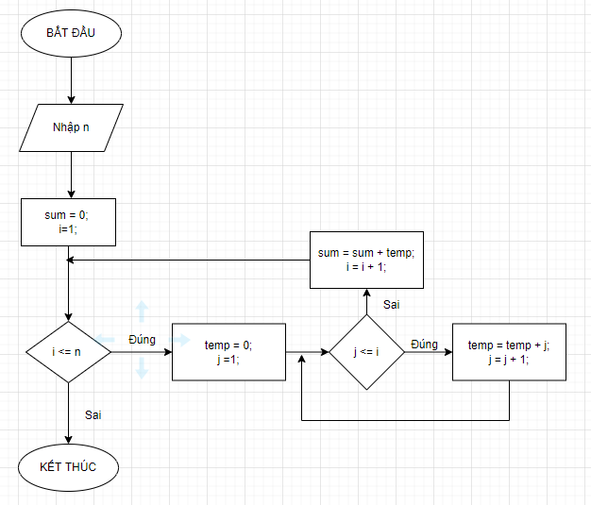

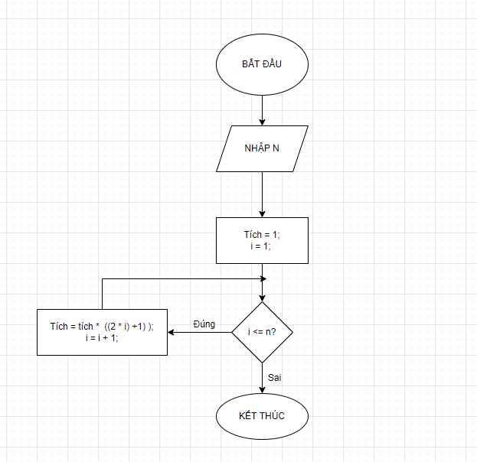

1.3

package CoSoLapTrinh;

import java.util.Scanner;

public class KiemTraCuoiKi {

public static Scanner sc = new Scanner(System.in);

public static int s(int n) {

int sum = 0, count = 0;

for (int i = 1; i <= n; i++) {

count += i;

sum += count;

}

System.out.println("S(n) = " +sum);

return sum;

}

public static int p(int n) {

int p = 1;

for (int i = 0; i <= n; i++) {

p = p * (2 * i + 1);

}

System.out.println("P(n) = "+p);

return p;

}

public static void main(String[] args) {

System.out.println("Nhập n: ");

int n = sc.nextInt();

int s = s(n);

int p = p(n);

}

}

Câu 2:

Package CoSoLapTrinh;

import java.util.Scanner;

public class KiemTraCuoiKi {

public static Scanner sc = new Scanner (System.in);

public static void main(String[] args) {

// TODO Auto-generated method stub

int n, i, b, j, temp, sum=0;

System.out.println("Nhap n: ");

n=sc.nextInt();

int a[] = new int[n];

System.out.println("Nhap mang: ");

for(i=0;i<n;i++)

a[i]=sc.nextInt();

System.out.println("Xuat mang: ");

for(i=0;i<n;i++)

System.out.print(a[i]+" ");

System.out.println(" ");

do {

System.out.println("Nhap yeu cau:");

System.out.println(" 1: Tinh tong cac phan tu trong mang 2: Dao nguoc vi tri cac phan tu trong mang ");

System.out.println(" 3: Sap xep mang theo thu tu tang dan ");

b=sc.nextInt();

switch (b) {

case 1:

System.out.println("Tinh tong cac phan tu trong mang : ");

for (i=0;i<n;i++)

sum += a[i];

System.out.print(sum);

System.out.println(" ");

break;

case 2:

j = i - 1;

i = 0;

while(i<j)

{

temp = a[i];

a[i] = a[j];

a[j] = temp;

i++;

j--;

}

System.out.print("Mang sau khi dao nguoc: ");

for(i=0; i<n; i++)

System.out.print(a[i]+ " ");

System.out.println(" ");

break;

case 3:

System.out.println("Mang sap xep theo thu tu tang dan : ");

temp = a[0];

for (i = 0 ; i < a.length - 1; i++) {

for (j = i + 1; j < a.length; j++) {

if (a[i] > a[j]) {

temp = a[j];

a[j] = a[i];

a[i] = temp;

}

}

}

for (i = 0; i < a.length; i++)

System.out.print(a[i] + " ");

break;

}

}while (b!=4);

}

}